总结报告23

论文Multi-task sparse structure learning with Gaussian copula models等

推导过程

（2020.3.17）

一、contents

Gonçalves, A. R., Von Zuben, F. J., & Banerjee, A. (2016). **Multi-task sparse structure learning with Gaussian copula models**. Journal of Machine Learning Research, 17, 1–30.

Feng, S., Ren, W., Han, M., & Chen, Y. W. (2019). **Robust manifold broad learning system for large-scale noisy chaotic time series prediction: A perturbation perspective**. Neural Networks, 117, 179–190.

二、论文1

Gonçalves, A. R., Von Zuben, F. J., & Banerjee, A. (2016). **Multi-task sparse structure learning with Gaussian copula models**. Journal of Machine Learning Research, 17, 1–30.

1. 理论基础：

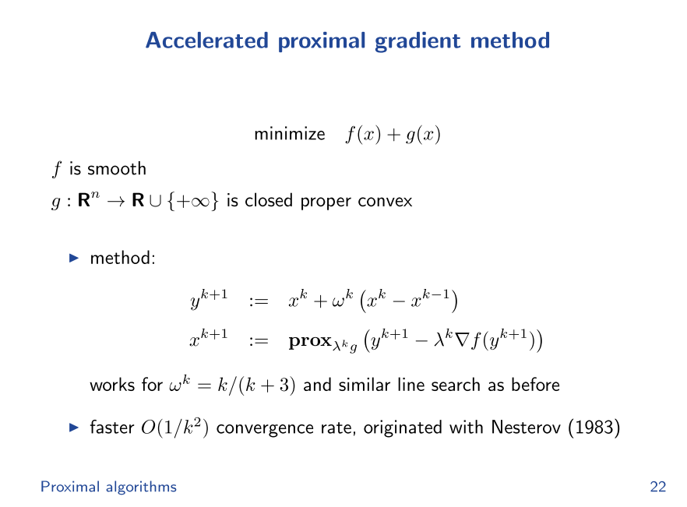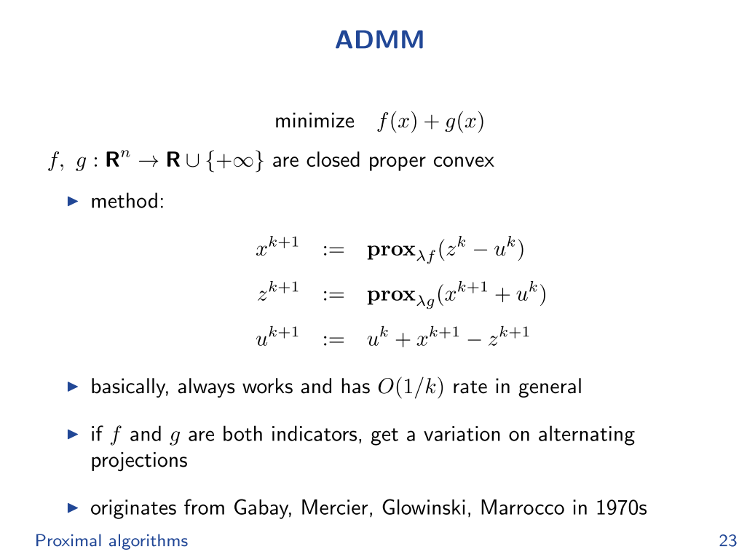

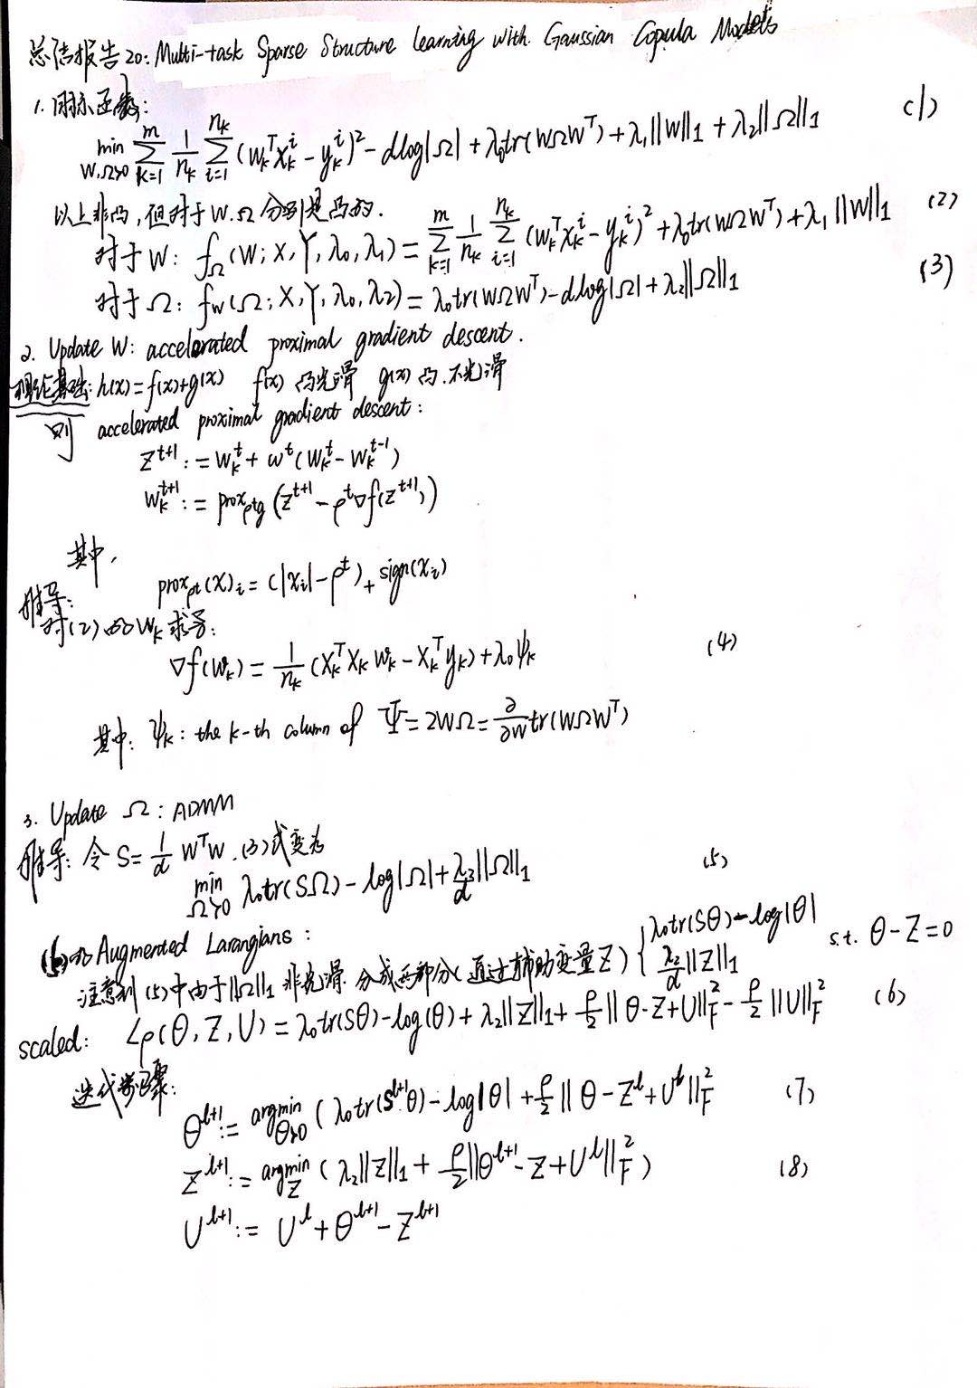

（8）的非凸优化问题可以利用逼近算法，例如下面的例子：

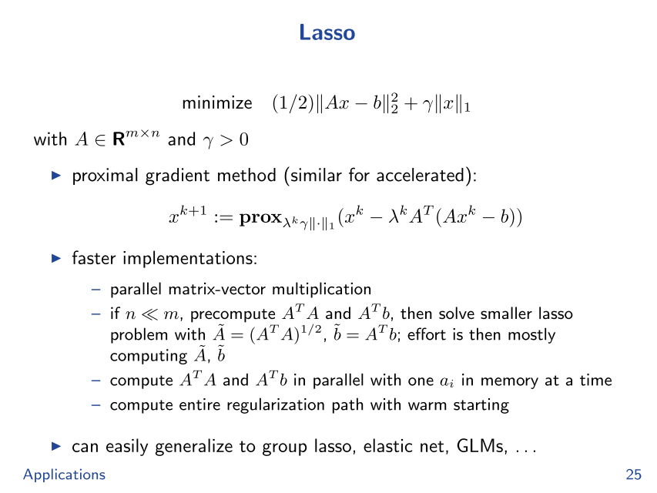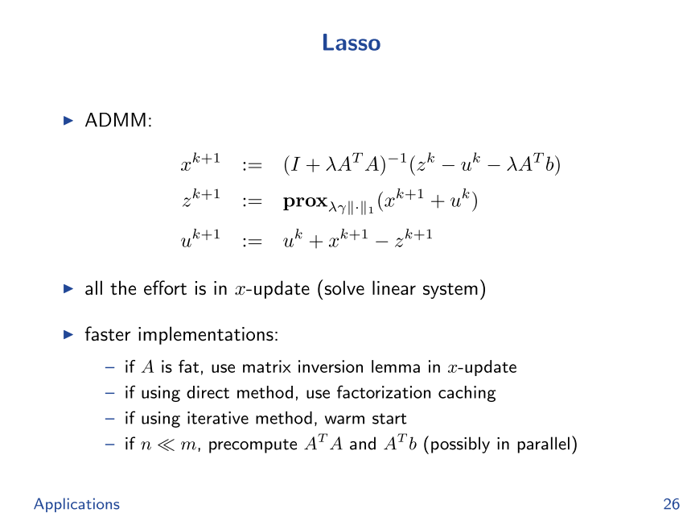

二、论文2

Feng, S., Ren, W., Han, M., & Chen, Y. W. (2019). **Robust manifold broad learning system for large-scale noisy chaotic time series prediction: A perturbation perspective**. Neural Networks, 117, 179–190.

1. 推导过程

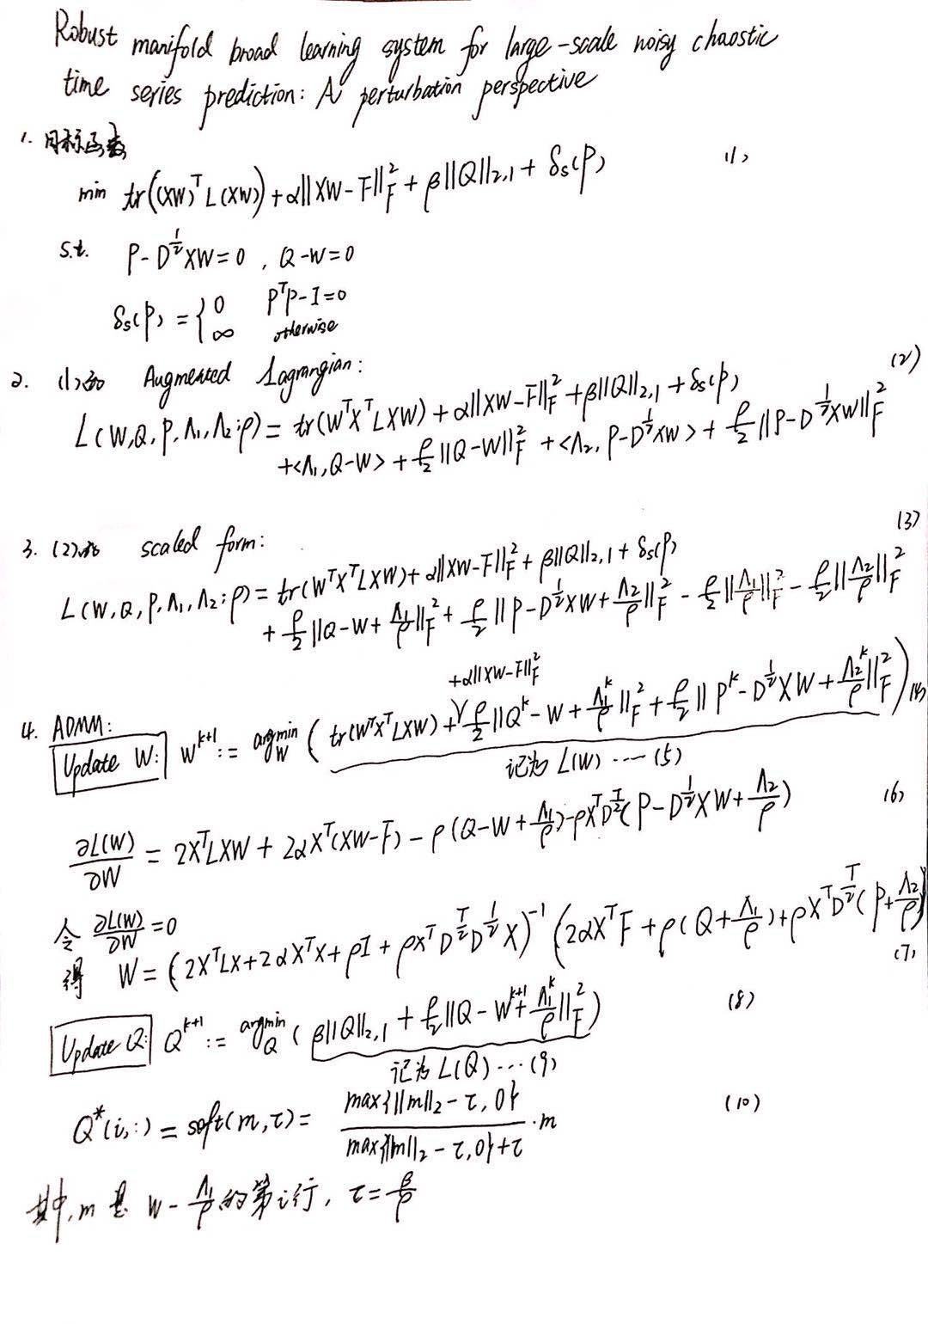

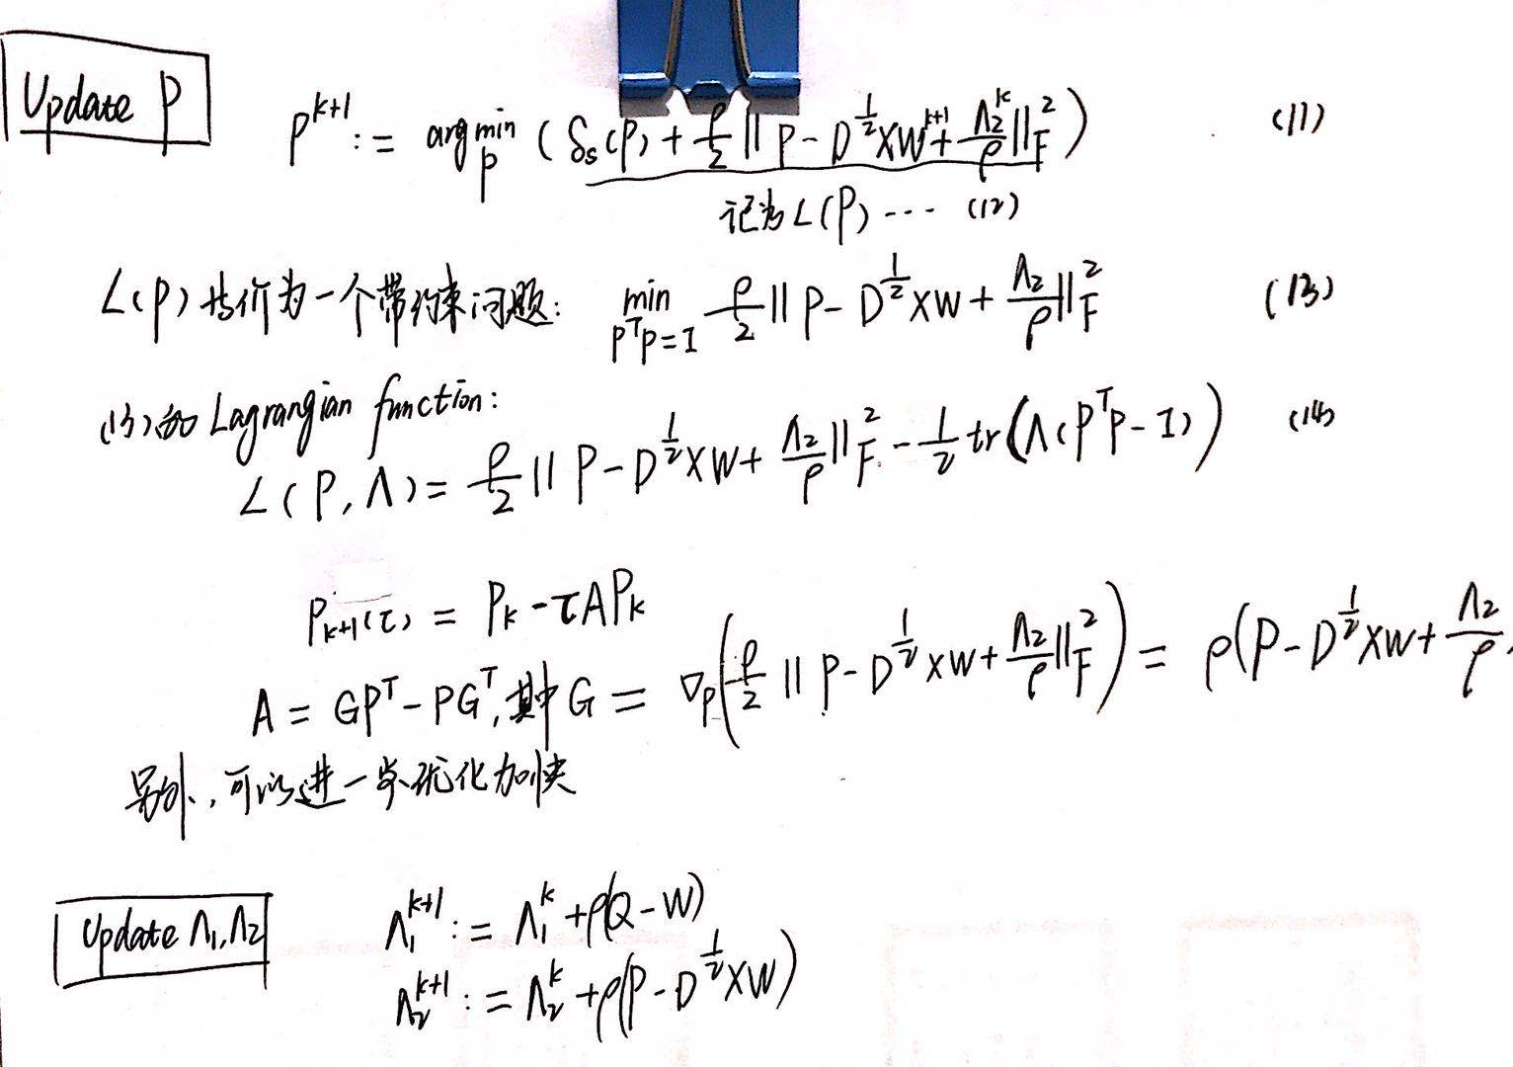

1. 一个小问题

上面手写笔迹的地方有一处画了红框，即W的闭式解，而原论文写的如下，那么

